Bacula

About:

Bacula is a set of programs that allow you to manage backup and recovery of computer data across a network. It is the most popular of the open source backup software, and available on most platforms. Fairly easy to install.

Part 1: Installation and Configuration for Server

1. Install bacula-director bacula-storage bacula-console mariadb-server

**sudo yum -y install bacula-director bacula-storage bacula-console mariadb-server**

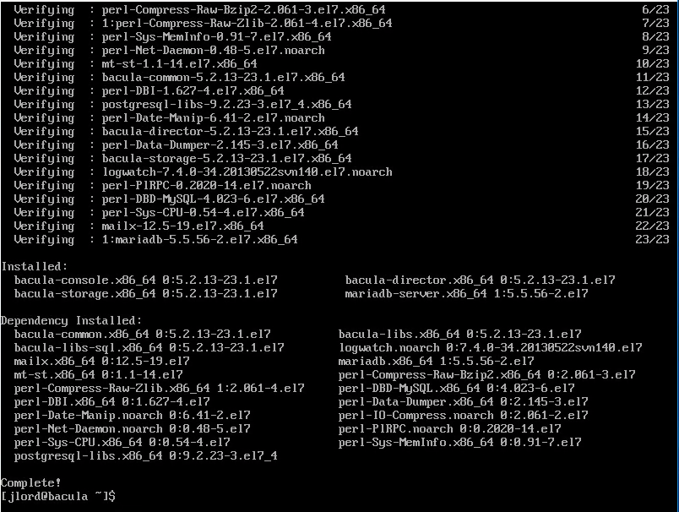

2. Start and enable mariadb

**sudo systemctl start mariadb**

**sudo systemctl enable mariadb**

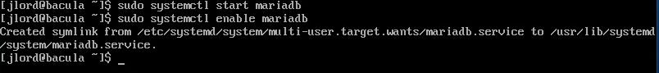

3. Go into my.cnf and add the following:

**sudo vim /etc/my.cnf**

**character-set-server=utf8**

4. Do the mysql installation

**sudo mysql_secure_installation**

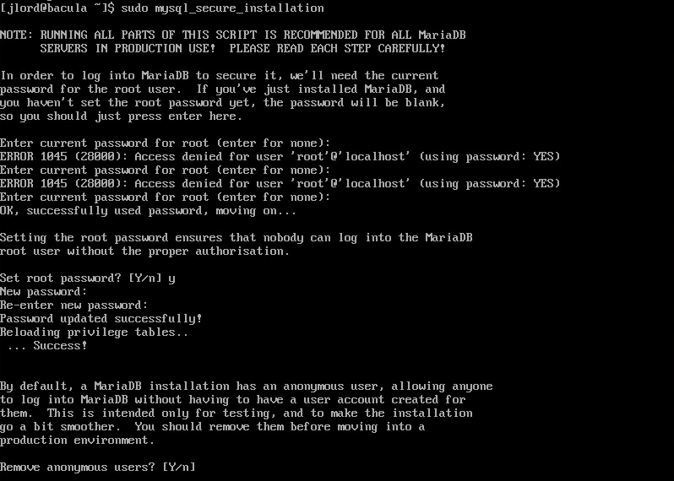

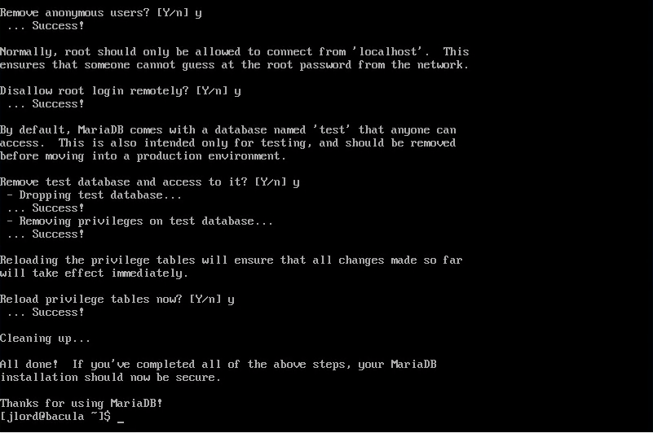

5. Add mysql to the firewall along with ports 9101,9102,9103 and reload firewalld

**sudo firewall-cmd –permanent –add-service=mysql**

**sudo firewall-cmd --permanent --add-port={9101,9102,9103}/tcp**

**sudo firewall-cmd –reload**

6. Change the selection for libaccats to mysql

**sudo alternatives –config libbaccats.so**

type 1

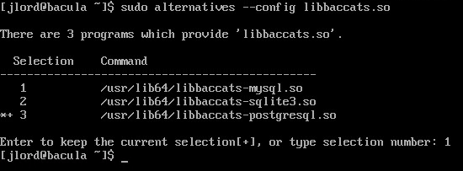

7. Go to root and grant mysql privileges and create a database and tables for bacula

**ls /usr/libexec/bacula/**

**/usr/libexec/bacula/grant_mysql_privileges -p**

Enter root password

**/usr/libexec/bacula/make_mysql_tables -p**

Enter root password

**/usr/libexec/bacula/make_mysql_tables -p**

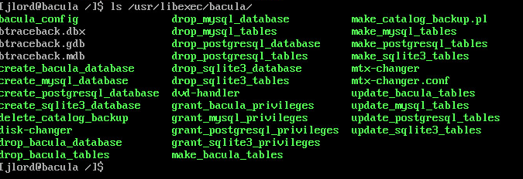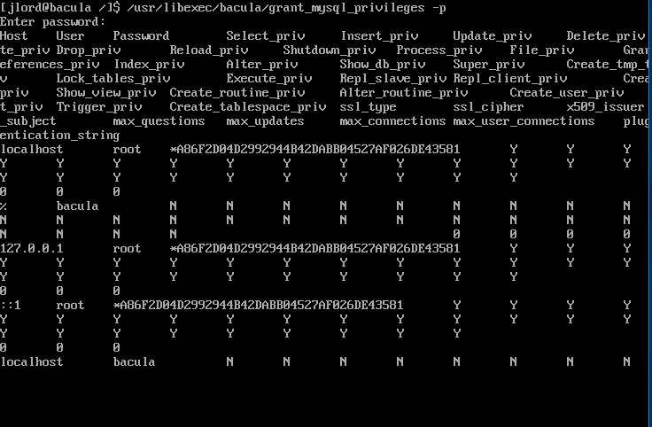

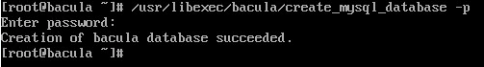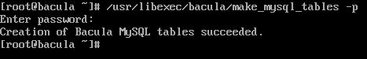

8. set mysql password for bacula database

**mysql -u root -p**

**enter password**

**set password for bacula=password('password');**

**set password for bacula@localhost=password('password');**

**select user,host,password from mysql.user;**

**show databases;**

**show tables from bacula;**

**use bacula;**

**exit;**

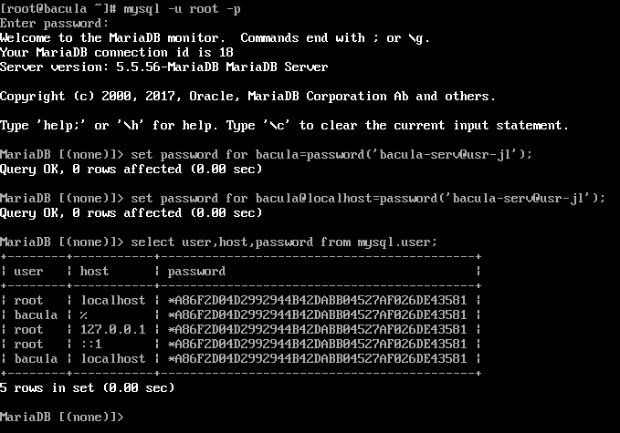

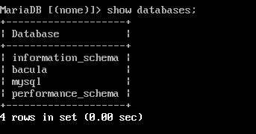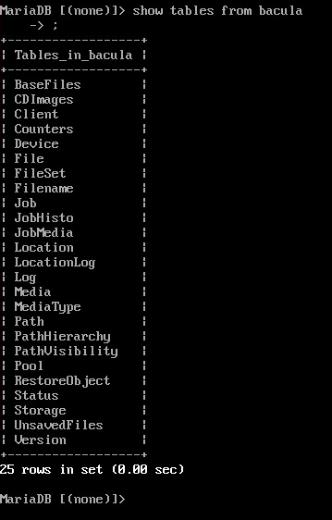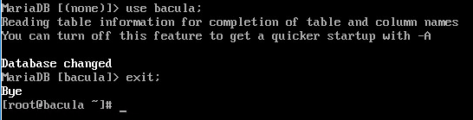

9. Edit bacula-dir.conf

**vim /etc/bacula/bacula-dir.conf**

go to line 22 and change password to your password



go to line 93 and add a new line Compression=GZIP

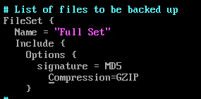

go to line 110 and change /usr/sbin to /data



go to line 158 and change localhost to IP address of the client



go to line 161 and change password to your password



go to line 187 and change address to server address

go to line 189 and change password to your password

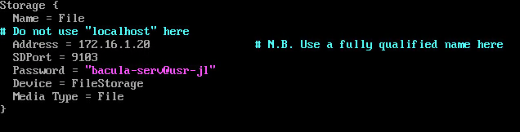

go to line 236 and enter your dbpassword



comment out lines 310-314

10. Edit /usr/libexec/bacula/make_catalog_backup.pl

**vim /usr/libexec/bacula/make_catalog_backup.pl**

go to line 109 and add -u$args{db_user} -p$args{db_password}



11. Start bacula-dir and check on its status

**systemctl start bacula-dir**

**systemctl status bacula-dir**

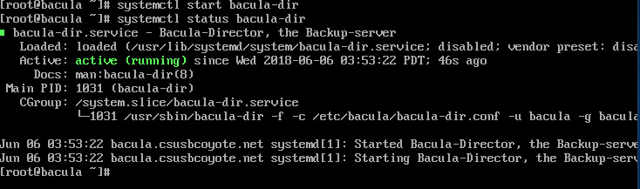

12. Edit bacula-sd.conf

**vim /etc/bacula/bacula-sd.conf**

go to line 26 and change password to your password

comment out lines 33-37

13. Start bacula-sd and check its status

**systemctl start bacula-sd**

**systemctl status bacula-sd**

14. make sure server is listening to bacula-sd and bacula-dir on ports 9101 and 9103

**netstat -ntpa**



15. Edit bconsole.conf

change address to servers IP address and the password to your password

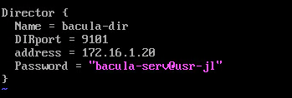

Part 2: Installation and Configuration for Client

1. Add the ports and to the firewall and reload

**firewall-cmd --permanent --add-port={9101,9102,9103}/tcp**

**firewall-cmd –reload**

2. Install bacula-client bacula-console bacula-console-bat

**yum -y install bacula-client bacula-console bacula-console-bat**

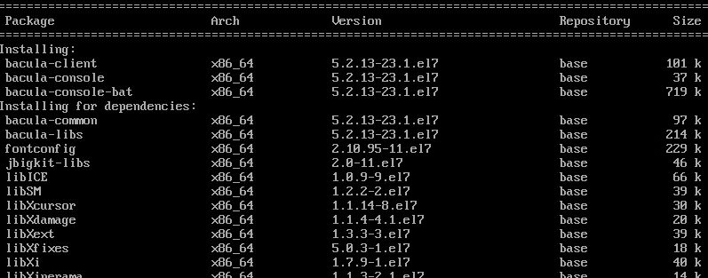

3. Edit bacula-fd.conf

**vim /etc/bacula/bacula-fd.conf**

got to line 15 and change password to your password

comment out lines 22-26

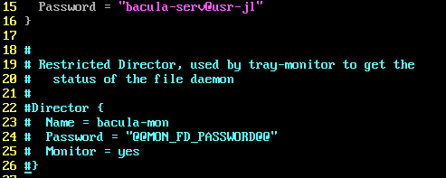

4. Start bacula-fd and check its status

**systemctl start bacula-fd**

**systemctl status bacula-fd**

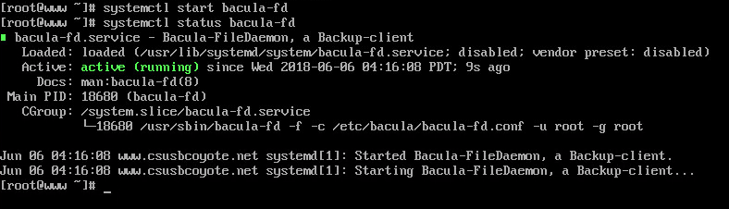

5. Edit bconsole.conf and bat.conf

**vim /etc/bacula/bconsole.conf**

change address to servers IP address and the password to your password

**vim /etc/bacula/bat.conf**

change address to servers IP address and the password to your password



6. Make a new directory called data

**cd /**

**mkdir data**

**ls**

Part 3: Testing

1. On Client:

**cp -a boot data**

**ls /data**

2. On Server:

**bconsole**

**label**

**test**

**2**

**exit**

**ll /tmp**

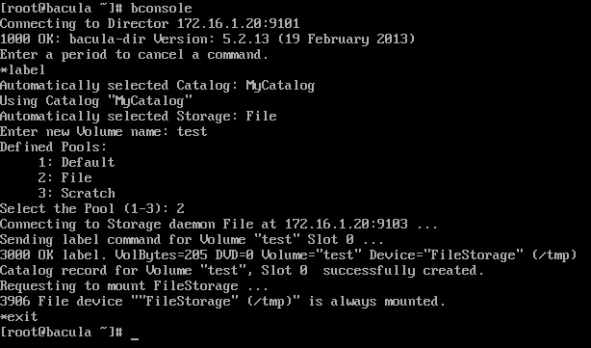

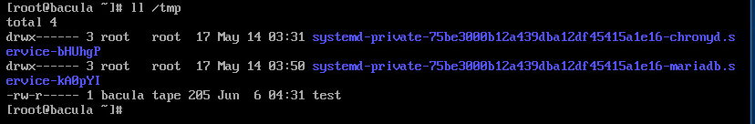**bconsole**

**run**

**1**

**yes**

**exit**

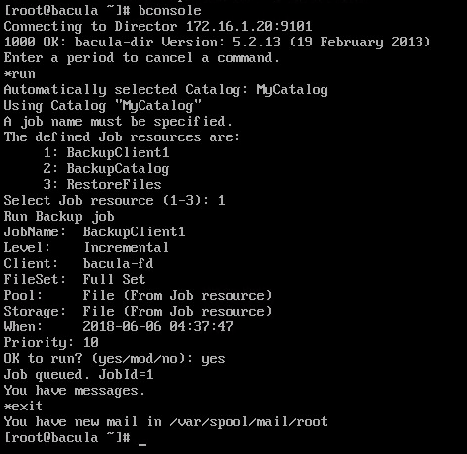

3. On Client:

**bconsole**

**restore all**

**5**

**done**

**yes**

**exit**

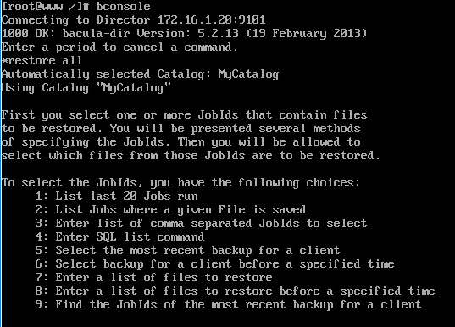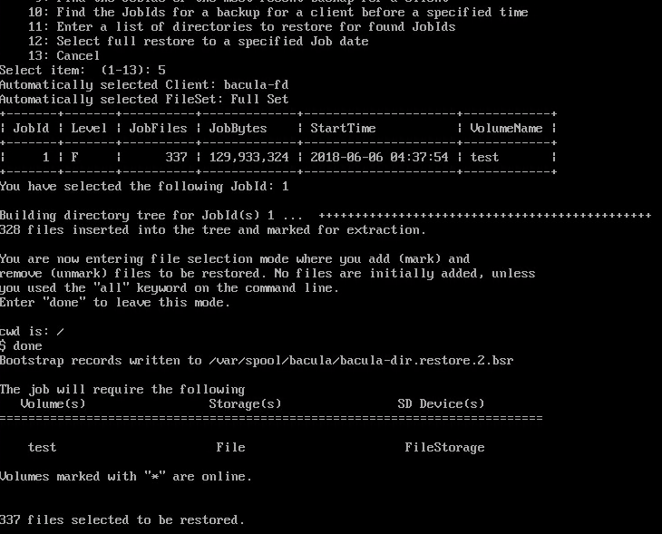

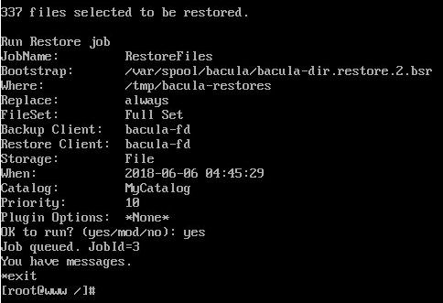

4. check tmp/bacula-restores directory for restored files